**Country State Master Data Module**

**Description**

Generally, the developer must manually prepare the master data for the country & their respective state.

A module for country master data, so that developers can directly import the module and they can have all the master data regarding countries & their respective states.

**Typical Usage Scenario**

If your application requires dealing with addresses from various states, and countries worldwide, you can consider incorporating a module that provides comprehensive data on countries and their respective states. By utilizing such a module, you can ensure accurate and up-to-date information for address management.

**PreRequisites**

NA

**Features and limitations**

Users can directly access the master data by creating an association with the module's entity.

**Dependencies**

1. Mendix Version – 9.1.1 or higher

**Installation**

1. Download the package either from marketplace or [CountryMasterData.mpk](https://nagarro.sharepoint.com/:u:/s/LowcodePractice-Mendixplatform/EQungubzotpLrEQPNcjjNb4BbBbeTtDv8EiT33UMfXuqLQ?e=facg4e) from given SharePoint location.
2. Import the module package into your project.

1. Configure security of application by providing access for respective module roles.
2. Add country overview page to navigation.

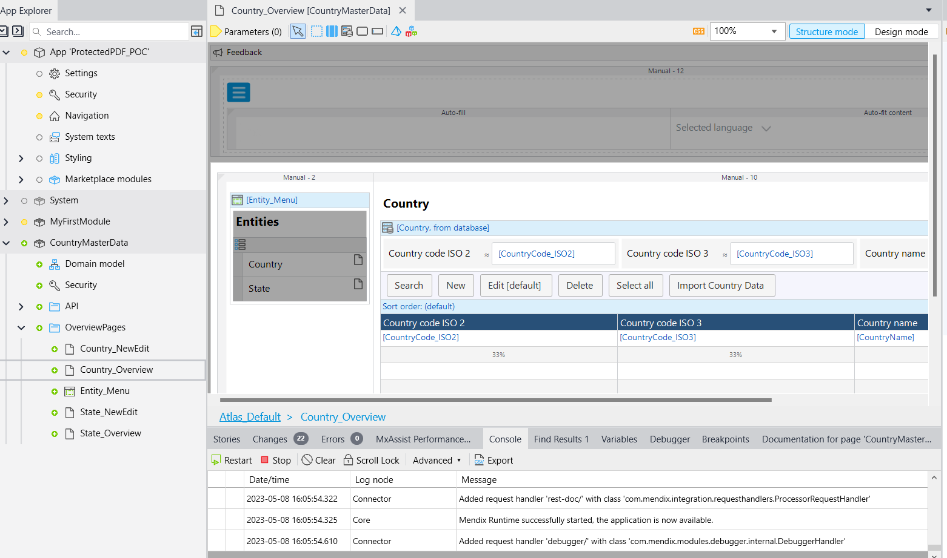

1. Run application and login with Administrator.
2. Navigate to the country overview page.
3. Click on Import Country Data button to import all countries & state data.

1. Once import is finished all the countries information will be shown on page, now you can use this master data in your project accordingly.

**Configuration: NA**

**Category: Module**

**Subcategory: All**

**Visibility: Public Marketplace**

**Studio Pro Version: 9.1.1**